SimPEG Meeting Minutes

Subject/Purpose | - Introduction to Python

Organizer’s Name | Luz Angelica Caudillo Mata |  |  | Date | 2013-06-26
Organizer’s Location | ESB 4013
Meeting date/ location | GIF room | from: | 12:00 | to: | 13:00

ATTENDANTS
No | Name | Initials | Rol
1 | Eldad Haber | EH | Participant
2 | Dave Marchant | DM | Moderator
3 | Lars Ruthotto | LR | Participant
4 | Luz Angelica Caudillo Mata | LACM | Participant
5 | Kristofer Davis | KD | Participant
6 | Seogi Kang | SK | Participant
7 | Jenn Fohring | JF | Participant
8 | Wing Wa Yu | WY | Participant
9 | Klara Steklova | KS | Participant

PRE-REQUISITES
Description | Who
Prepare Python introductory tutorial | DM

AGENDA
Hours of |  | Time (min) |  | No | Topics | Discussion  Leader
Start | End | Plan | Real | No | Topics | Discussion  Leader
12:00 | 13:05 |  |  | 1 | Sushi | All
 |  | 60 | 65 | 2 | Python introductory tutorial | DM

Totals | 60 | 65

ACTIVITIES, ACTIONS AND IMPORTANT INFORMATION
No | What | Who | When
1 | Program the class mesh such as it generates the nodal and staggered grids. This class should be able to plot part of the mesh. | LACM  LR | 2013-07-03
2 | Put tutorial notes in Bitbucket repository | DM | 2013-07-03
3

Notes

MEETING SUMARY

- Introduction to Python
DM created an interactive notes to demonstrate some of the Python capabilities. This notes are self explanatory and contains some useful links and sources. This notes will be uploaded to the SimPEG repository sometime in the following week.

- EH commented that week by week we will construct the building blocks to obtain the code for the Maxwell's Equations in Frequency Domain using orthogonal meshes. The idea is to have this code ready by the end of July.

For the following week LR and LACM will be the volunteers to code the class mesh.

AGREEMENTS

- Every week we will switch volunteers to code building blocks.
- For the axis orientation we will use the “Right-hand rule”
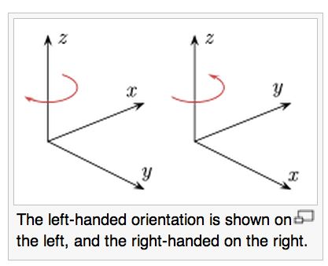
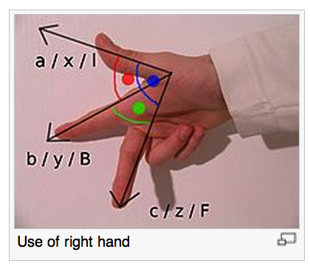

*Pictures taken from Wikipedia: http://en.wikipedia.org/wiki/Right-hand_rule

COMMENTS AND OTHER TOPICS TO BE DISCUSSED IN FURTHER MEETINGS

